TASK 1
- Create a directory called ""my_folder"", navigate into it, and create a file named ""my_file.txt"" with some text. Then, create another file named ""another_file.txt"" with some text. Concatenate the content of ""another_file.txt"" to ""my_file.txt"" and display the updated content. Finally, list all files and directories in the current directory.
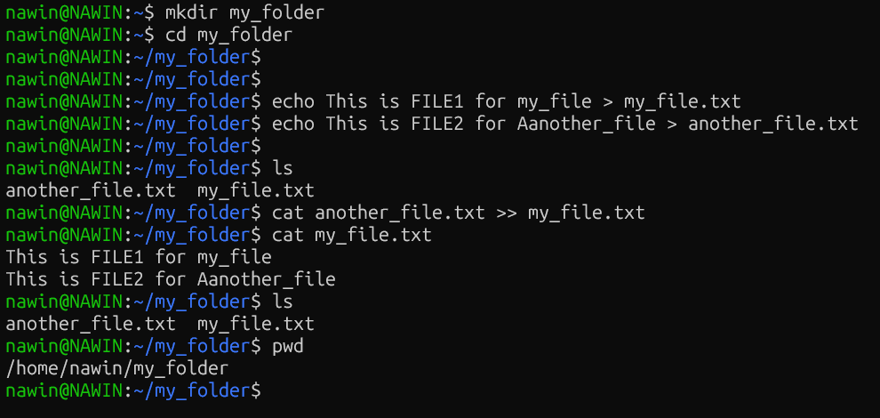

TASK 2
Creating 20 file.txt
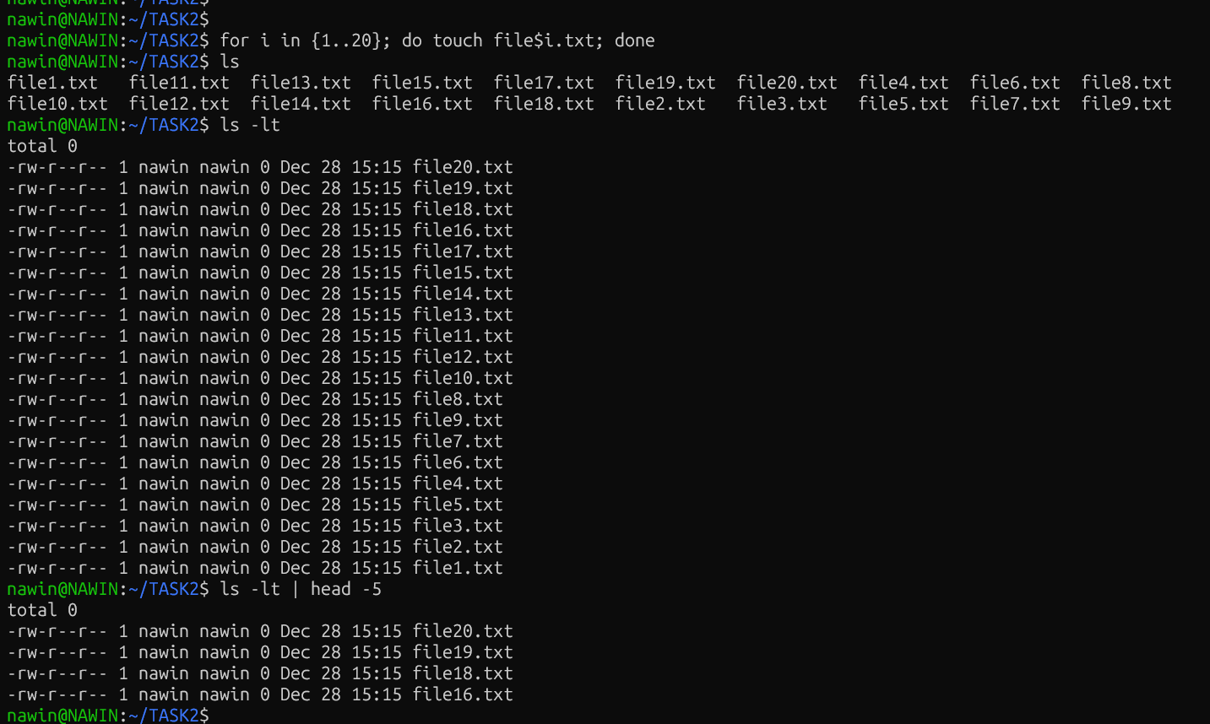

Changing 1-5 file.txt to file.yml
